Homework: Installing Software
Making a user part of group sudo
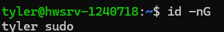
Using the id command with options -nG it displays the user’s group they belong to. In this case it shows me has a user in the user group sudo.

Corrctly installing tree package to ubuntu
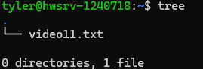
Using the tree command it shows the directories and files. In this case it shows my one file that was made named video11.txt while displaying 0 directories found.

